

SEO AUDIT REPORT

**WEBSITE:**

**https://www.mantrapaancafe.com.au/**

Regards,

**Pixemsoft**

https://pixemsoft.com/

+92306567839

# 

SEO AUDIT REPORT SUMMARY

**Dear Client**,

We have analyzed your website to find out its search engine optimization friendliness. A conclusion has been given in a report describing how to improve your website.

**This Report contains the following:**

* On-PageSEOAnalysis
* Off-PageSEOAnalysis
* Technical Analysis
* Traffic Analysis

**Client’s Website**

<https://www.mantrapaancafe.com.au/>

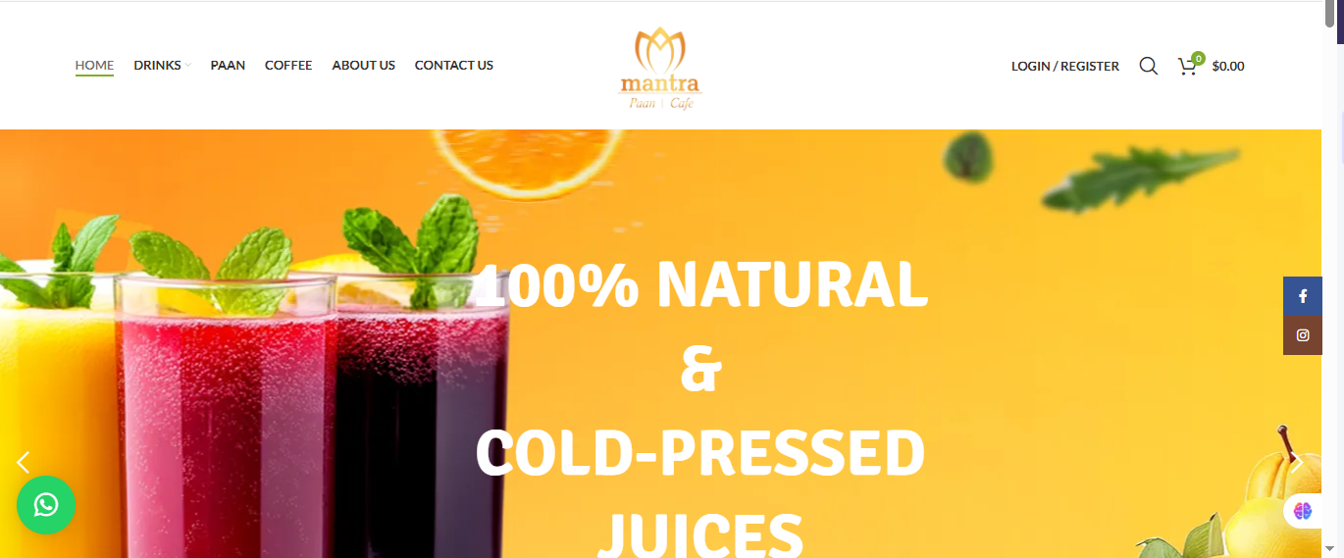

Regards,

**Pixemsoft**

https://pixemsoft.com/

+92306567839



1. OFF PAGE SEO ANALYSIS

The information in this section is based mainly on the links on your website and the number of pages that are currently indexed by search engines

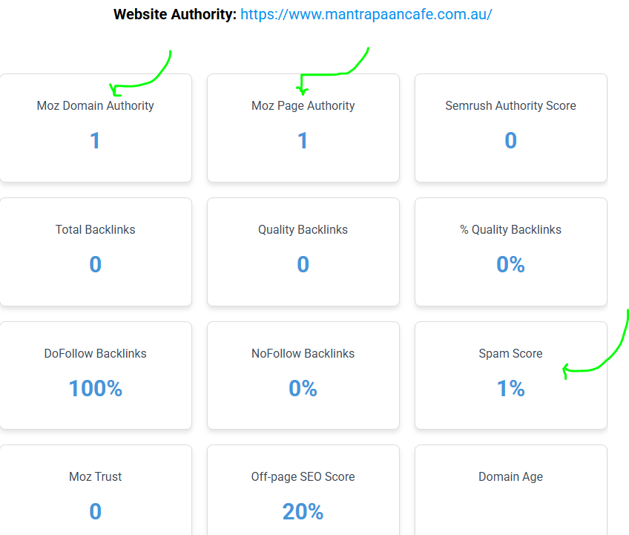

* Domain Authority (DA) = 1 out of 100
* Page Authority (PA) = 1 out of 100
* Spam Score=1 %
* Domain Age= This Domain age is not detected



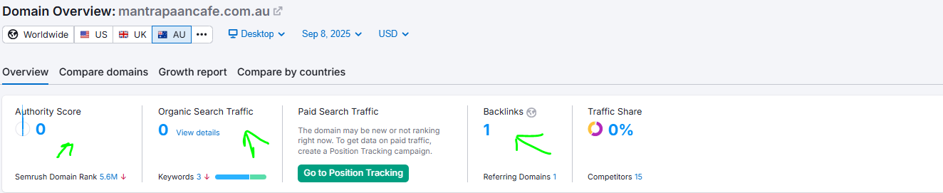

* Total Backlinks = 0
* Referring Domains = 1
* Do Follow Links =1 (100%)
* No Follow Links =0 (0%)
* Text Links =1 (100%)
* Images Links = 0 (0 %)
* .edu&.gov Links =non



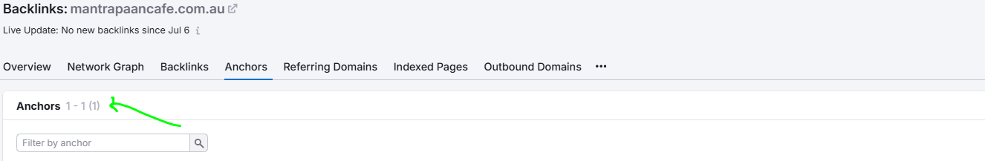

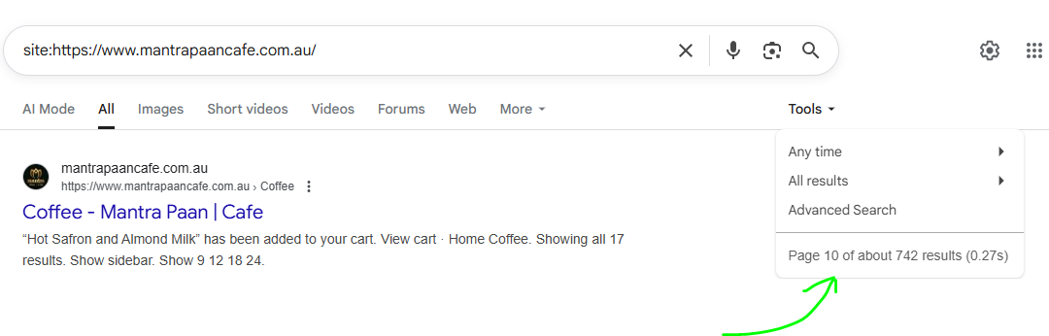

* Total Anchor Text Use = 1-
* Indexed Pages in Google = 10 Pages

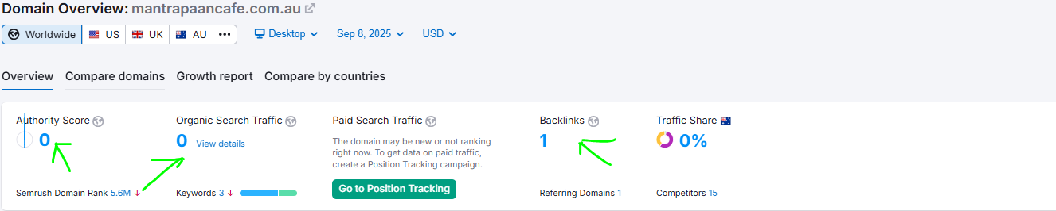

* Organic Traffic = 0 Users



* Currently Website has just 1 backlinks directed to it. It's crucial to understand that the number and quality of backlinks are significant factors in determining your website's authority.
* Backlinks from reputable and relevant websites act as votes of confidence, signalling to Google that your website can be trusted. Google values websites that are seen as trustworthy and authoritative sources of information.
* Websiteswith higher authority are more likely to rank higher in search engine results pages (SERPs). By building quality backlinks and authority, we increase the likelihood of your website ranking higher for targeted keywords.
* Asyourwebsite's authority grows, it becomes more visible to your target audience, leading to increased organic traffic. This means more potential customers discovering your services. Wewillworkonthelink building and develop well planned strategies in order to gain backlinks from authoritative sources to further boost your online reputation.



1. Technical Analysis

Here are some other issues you need to pay attention to these issues as they directly impact your client's search engine ranking, but your content is good.

1. Home Page Content : 1334 Words

In terms of search engine results, Google loves pages with **quality content**, and the homepage of your site is the most important page for this. According to our analysis, your homepage content above the ideal 400 to 500 words for SEO. That is Good.

The more content we have, the greater the potential SEO value of our page. If there is anything we can do to help, please let us know. The content on this page plays an important role in SEO Rankings on your site!  
Now we change the this content in a few days and write a content about keyword base.



1. Website Loading Speed Issue

No Need to optimize the loading speed of this website for mobile & Desktoo Devices

Take a look at this:

**Website Mobile Speed:**

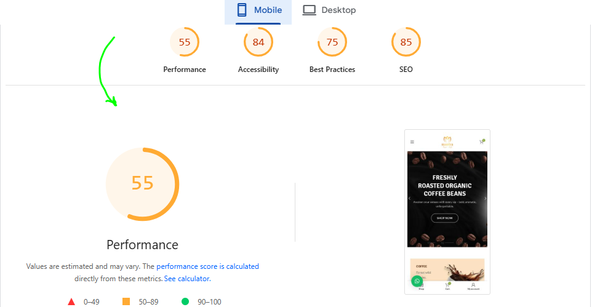

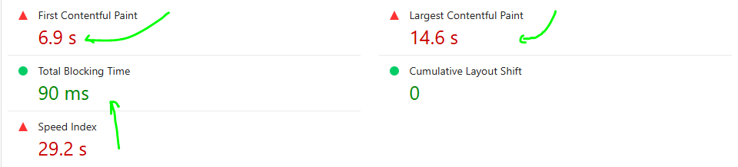



**Website Desktop Speed:**

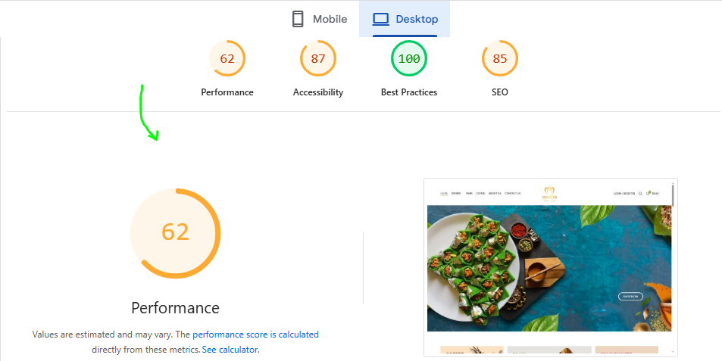

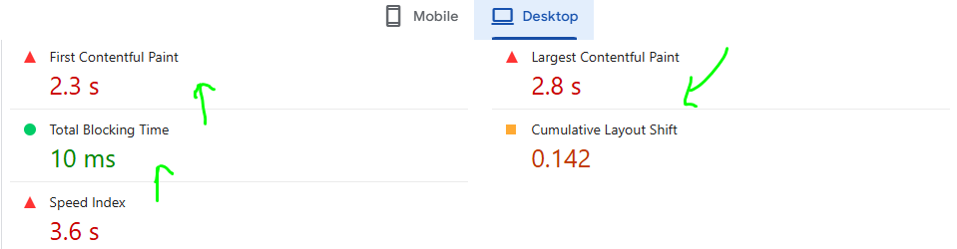

Recent Google policies and updates indicate that website loading speed is an important ranking factor. After analysing your website, we determined that it needs to be improved in terms of loading speed for both mobile and desktop versions. You Need to Optimize LCP, FCP,TBT.



1. Website Responsive issue

You have not a responsive website at the momen



* In Google search results, websites that are mobile-friendly have a better chance of ranking higher. As a result, you may be losing sale opportunities and traffic from mobile phones and tablets due to your poor performance on these smaller screens.
* If you want to rank highly in all Google searches regardless of the device used. Our website is currently not responsive, so there is not need to worry about.



1. SSL (Secure Sockets Layer

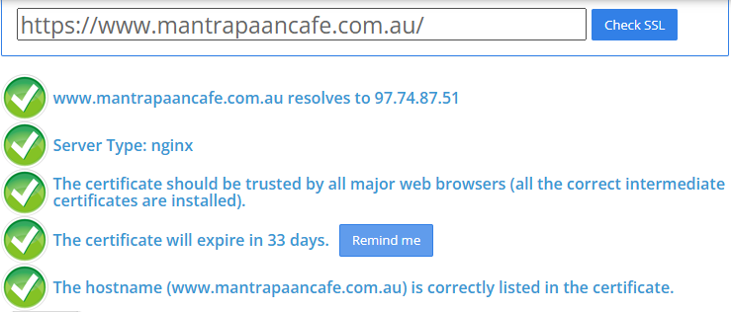

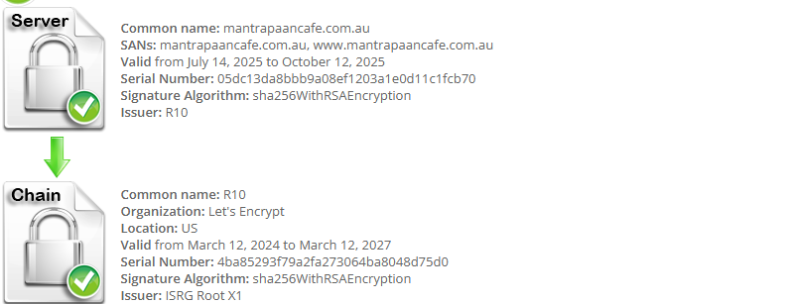

Google confirms that SSL certificates improve the ranking signal for your website. There is a strong correlation between first-page Google rankings and SSL-encrypted sites



5. Blog Posts on Website

You do not add blogpost page to your site.

* The purpose of blogs is to attract people who are searching for information and then convert them into leads by offering them unique promotions. A blog post is an opportunity to highlight the website's expertise and services. By addressing common problems, answering frequently asked questions, and demonstrating solutions, they can attract potential users looking for solutions.
* Your site lacks new content, and Google loves it. Consistently adding new content always boosts a site's ranking.
* Fresh content is rewarded by search engines and it will make your website more appealing to your target audience, so you should update your website frequently with unique content that your audience will enjoy.
* At least two posts per week are the best way to ensure the site is continually updated with content. Your rankings will benefit greatly from this, as well as engaging your viewers with new and interesting content.



8 - Sitemap.xml

Your site has the file of Sitemap:

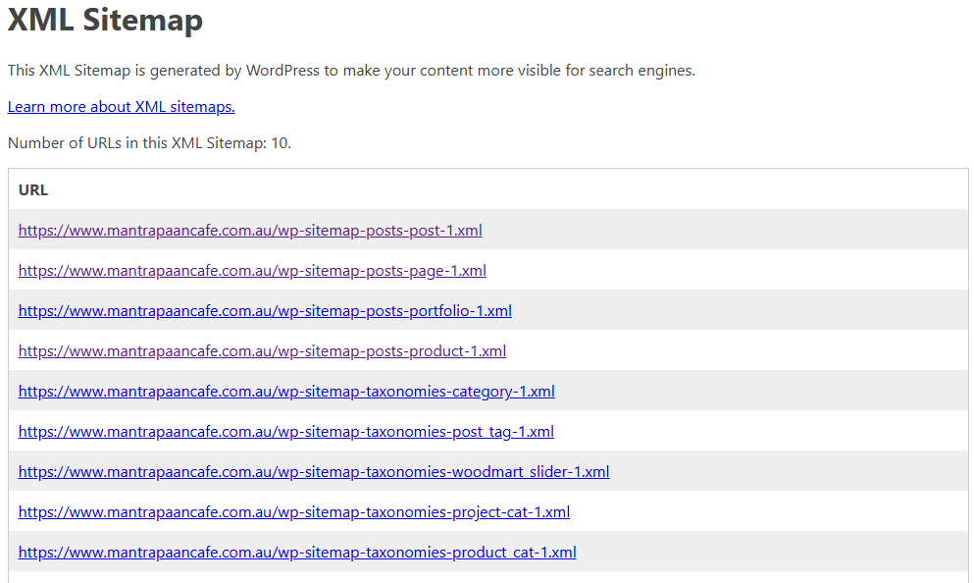

* Sitemape will help you index your pages in Google more quickly, as well as inform you when your pages were last updated.
* You can use a sitemap to tell search engines which pages and files are important on your website as well as provide information about them.
* Including a properly constructed sitemap in a website can have a tremendous impact on its search engine ranking, In addition to making navigation easier for search engines, sitemaps can also provide end-users with important page links



9- robots.txt File

Your site has the file of robots.txt

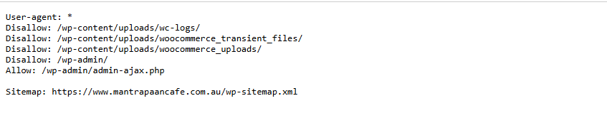

* The robots.txt file tells search engines which pages to index and which to skip. It helps search engines index the content of websites for many webmasters.
* Their most valuable pages will be more likely to appear in search engine results pages. It is essentially a way to make it easier for the spiders to return the most relevant search results by using robots.txt.
* This file saves Google's time when reading or indexing pages that you don't want Google to index and optimize crawl budget



3. Kewords Analysis

1. **Keywords:**

* The website <https://www.mantrapaancafe.com.au/> currently shows 3 existing keywords.
* You need to do new keyword research for your website and its pages.
* Choose Long tail keywords with high search volume and low keyword difficulty to rank higher.
* **green tea mango mantra**
* **ice gola**
* **ice gola near me**



1. ON PAGE(ERRORS)

An in-depth analysis of on-page SEO errors of your website is provided in this section of the report, along with recommendations on how to fix them.

Diagnostics and Errors

1. **Critial Errors:**

The website <https://www.mantrapaancafe.com.au/> **home page and other pages** found a some issues:  
**Title:** Not set a title this page ( Title should bhi **50 to 60** characters every page)

**Meta Description:** Found a Meta description this Page (Description Should bhi 160 chara all pages)  
**Headings Tag:** We found a not home page proper heading structure like h1, h2 , h3  
**Image Alt Text:** We found 53 images at home page have missing without alt text and title.  
**Schema markup:** Not implemented Schema markup this website.  
**Open Graph :** Not implemented Open Graph Tag  
**Twitter Card:** Not implemented Twitter Card

1. **Broken Links:**

We found one page 404 broken link

<http://www.mantrapaancafe.com.au/> product-category/milk-shakes/.

This page header and footer both are 404

We find a many broken links in this page

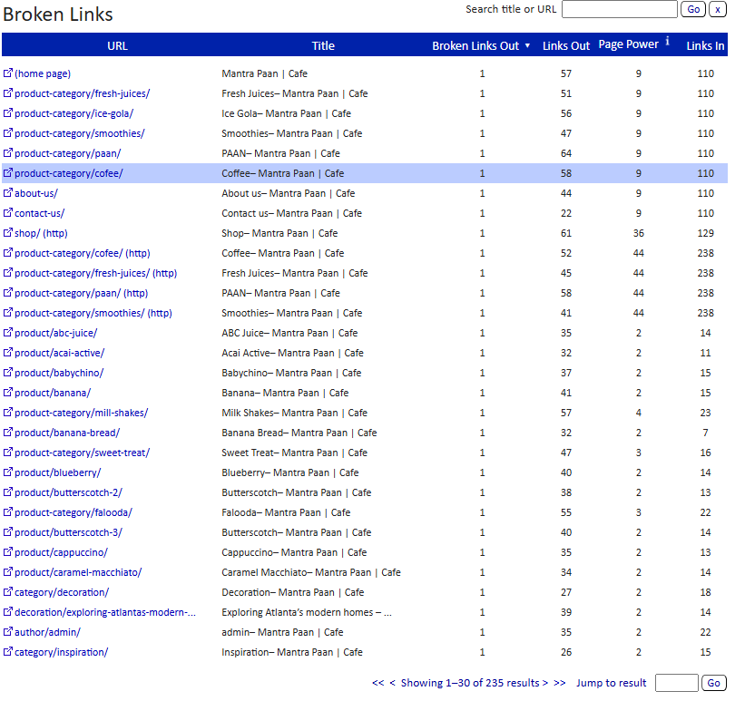

1. **Social media Platform:**

We do not see any social media platform mobile version website like:

1-Facebook

2-Linkedin

3-Instagram etc.



**Content Analysis**

Content is basically the backbone of any website and a key to rank better on SERPs. Your website currently do not have enough content as your competitors do. We need to add more content on our website and define our services properly.

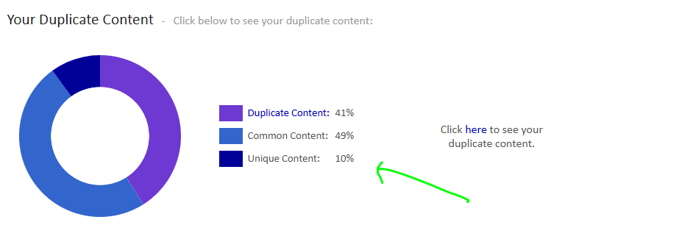

* Your website content is duplicate and its percentage is 42%.
* You need to fresh and quality content and human written for your website.
* Only this website 10 percent unique content.

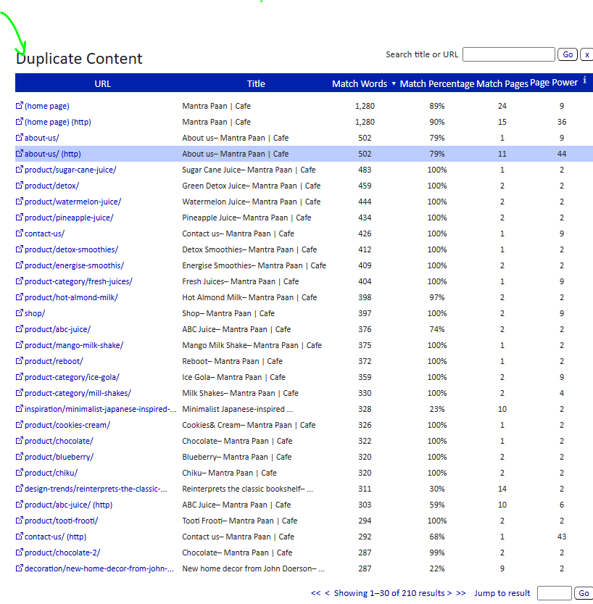

Now this pages have mostly duplicate content we found some pages. We change this content in few days.

**Missing Pictures:**  
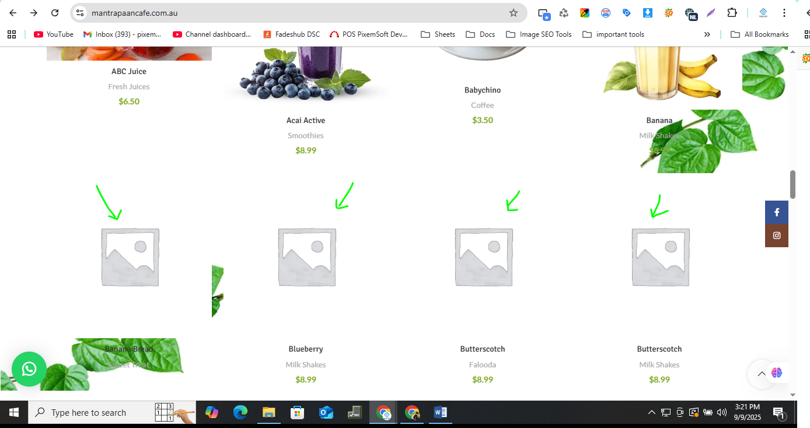

* We Found **missing pictures** in home page.
* Pan café page have many missing pictures



This month, we started **SEO** work on <https://www.mantrapaancafe.com.au/>. Our **ranking plan** will run for at least **three months** to get good results.

### Social Media Integration:

The social media platforms are already integrated in the website. These social media platforms play an important role in getting traffic and users to the website.

### On-Page Fundamentals:

These are the foundational elements that you need to implement directly on your website to optimize it for search engine result pages to rank higher. They play a crucial role in conveying relevance and value to your content. These are:

* Keyword Research
* Website Architecture
* Content Optimization According to keywords Research
* Visual Assets
* URL Optimization
* Page Title
* H1 & H2 Tags
* Image Alt Attributes
* Meta Description
* Setting Up Google Search Console
* Setting Up Google Analytics
* Optimizing the Blogs

### Off-Page SEO

In off page SEO backlinks are created. These backlinks are important for the ranking of the website in search engine result pages. There are multiple types of backlinks. These are:

* Blog Comments
* Profile Links
* Guest Posts
* Web 2.0
* Local Business Listing
* Article Submission
* PPT Submission
* Forum Submission

### Technical SEO

In technical SEO we perform a complete check of possible errors the website can have. Errors likes crawling and indexing issues and others as well. These technical issues include:

* Identifying crawling Issues
* Coverage Issues of website
* Website Speed Issues
* Fixing Broken Links
* Fixing Errors in Google Search Console
* Internal Errors in the website

This SEO audit report serves as a compass, guiding your website towards the peaks of digital success. Armed with these insights, you're equipped to steer your online presence towards higher visibility, enhanced user experience, and ultimately, greater success.

If any aspect of this report leaves you with lingering queries, please don't hesitate to reach out. I am dedicated to your website's triumph and stand ready to provide any assistance necessary to illuminate the path ahead.

Thank you for entrusting us with your digital journey. Here's to a future filled with optimization, growth, and achievement.

